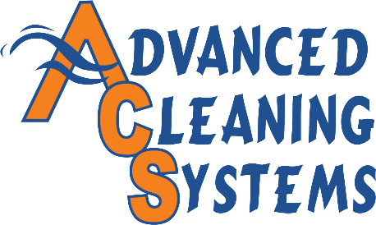

WHO’S DOING YOUR WORKPLACE SPRING CLEANING?

Spring cleaning is a necessity! Not only does it improve productivity in your workplace it also increases energy levels. Spring cleaning removes allergens making your employee’s happier and healthier, reduces stress, and keeps your employee’s focused. Included, please find our free workplace spring cleaning checklist that you can perform yourself or leave it to the professionals and hire Advanced Cleaning Systems to do it for you. ACS will gladly provide you with a free quote along with 20% off of your total bill for all spring cleaning services. Let us show you what ACS can do!
Contact us to set up a consultation or for inquiries by calling our office number below and asking for Kevin or Sonya. You may also go to our website at www.advancedcleaningllc.com to contact us and to see all that ACS has to offer.

Advanced Cleaning Systems, LLC.
2611 Charlotte St. Erie, Pa 16508
Ph: 814-866-1336
Fax: 814-528-5536
Website: www.advancedcleaningllc.com
Owner: Kevin Kreidinger: kevinkreidinger@advancedcleaningllc.com
Office Manager: Natalie Kreidinger: nataliekreidinger@advancedcleaningllc.com
Operations Manager: Sonya Smith: sonyasmith@advancedcleaningllc.com
HR-AR/Payroll: Susan Berthold: advancedcleaningsystems1@gmail.com
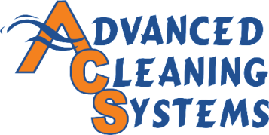
SPRING CLEANING CHECKLIST FOR YOUR BUSINESS
www.advancedcleaningllc.com

Lobby or Entrance
- Clean all glass top to bottom/ in and out leaving it streak free
- Wash salt and dirt off glass trim
- Vacuum Vents
- Wash walls from top to bottom. Rid of all scuff marks and pay special attention to the salt buildup on the bottom of the walls.
- Remove salt and dirt from corners and edges of carpet or tile then sweep the full floor
- Scrub tiles or shampoo carpet to remove all traces of salt
  - Freshen carpets with a carpet deodorizer
Lunch Area
- Vacuum Vents
- Wash windows in and out and wipe sills clean
- Wash walls from top to bottom
- Disinfect and wash sinks, counters, chairs, tables, and trash cans (Be sure to use the disinfectant properly!)
- Sweep, disinfect, and mop floors paying special attention to corners and edges.
  - Strip, scrub, and wax tiles to give it a fresh high gloss finish.
  - Disinfect and scrub carpets to get those salt stains out and leave it with a fresh smell.
Offices/Conference rooms
- Vacuum Vents
- Dust and wipe clean all desks, chairs, and trash cans (inside and out)
- Wash walls from top to bottom
- Sweep, disinfect, and mop floors paying special attention to corners and edges.
  - Strip, scrub, and wax tiles to give it a fresh high gloss finish.
  - Disinfect and scrub carpets to get those salt stains out and leave it with a fresh smell.
Restrooms
- Vacuum vents
- Disinfect entire restroom including walls, stalls, sinks, trash cans, and toilets. (Be sure to use disinfectant properly!)
- Wash walls, stalls, sinks, and toilets from top to bottom. Use stainless steel where necessary to leave fixtures shiny.
- Sweep, disinfect, and mop floors paying special attention to corners and edges.
  - Strip, scrub, and wax tiles to give it a fresh high gloss finish.

